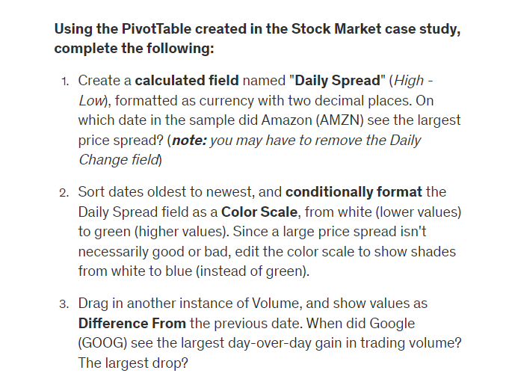

1. 10/23/2009  
   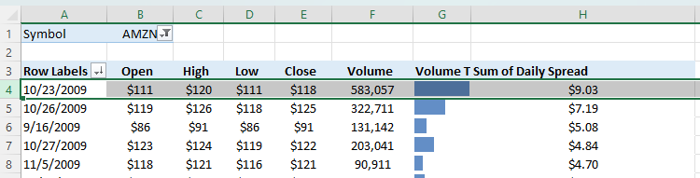
2. 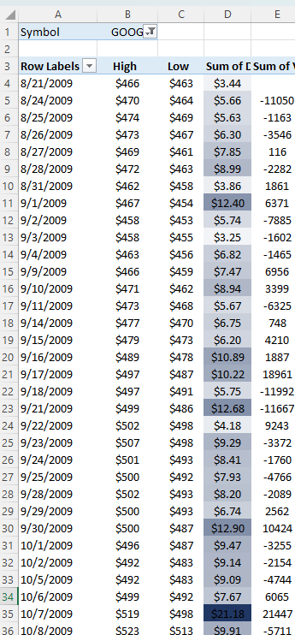
3. 10/15/2009 28356 & 10/19/2009 -56256  
   